## requirements

* design and development of longer lasting, more durable water pump station for rural communities without electricity access

## Ideas

* change of pump actuator
* Using of mechanical bicycle drive instead of hand pump
  + convert rotation from bicycle to mechanical power for pumping water
  + or convert to electrical power as alternative for solarpanel generation (lower invest for electrical system)

## Need

* research on existing projects
* Design concept
* Possible description for student project work (like bachelor/ master thesis)

## First Design Concept

* 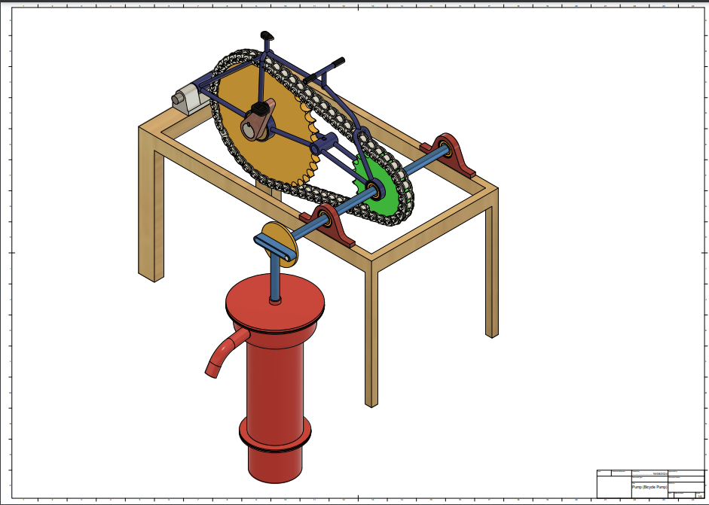

## Existing concepts

* Appropedia
  + <https://www.appropedia.org/Water_pumps>
  + Hydraulic ram pump: <https://www.appropedia.org/Hydraulic_ram_pumps>

General:  
- open-source CAD tool proposal

* <https://openscad.org/>
* <https://cadquery.readthedocs.io/en/>